**SPIDER SOFTWARE TASK-1**

**DOMAIN-SPECIFIC TASK : COMPUTER NETWORKING**

**1. DNS Server Mapping Module:**

DNS (Domain Name System) Servers translates the domain names into IP address that computer use to communicate over a network. They store DNS records and respond to DNS queries from clients, which can be other computers or devices on the network. The clients send a request to the Web Servers by giving its IP address which then responds by giving the content of the Web Page.

When a use enters a domain name in their web browser, the user’s device sends a query to the DNS server, the DNS server checks its cache to see if it has the IP address of the domain name, if it does then it returns the IP address to the device. If the IP address is not in the cache, it forwards the query to a root DNS server. Root server directs the query to the appropriate top-level domain (TLD) servers i.e (.com,.org,.net), the root server responds with the address of the TLD server for the domain, then the server requests the TLD server. The TLD responds with the address of authoritative DNS server then it requests the authoritative server, this authoritative server responds with the IP address of the domain name. The server caches this information for future requests and returns this address to the user’s device. The user’s device uses this resolved IP address to establish a connection with the web server and hosts the requested website.

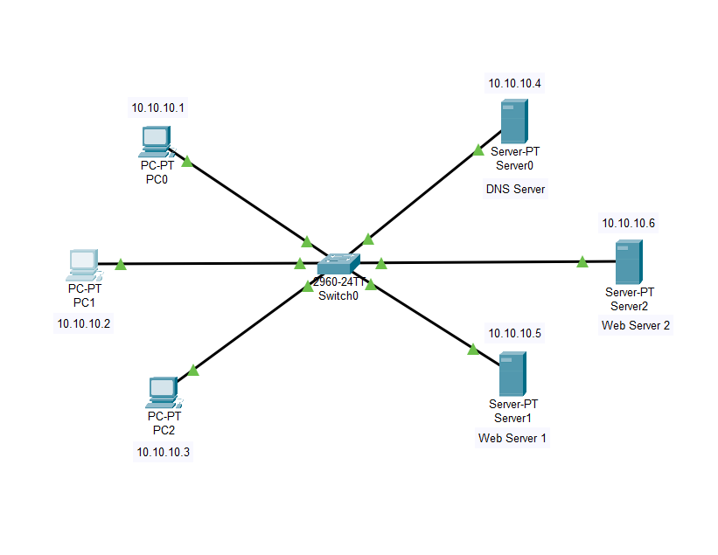

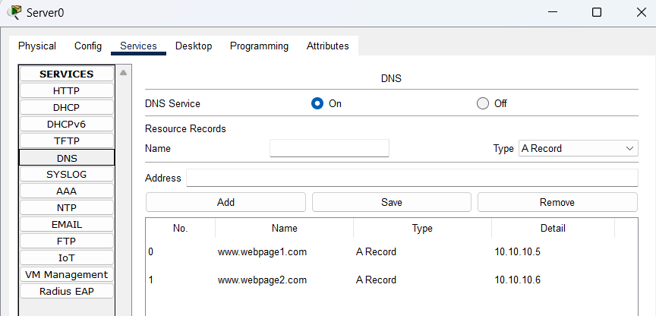

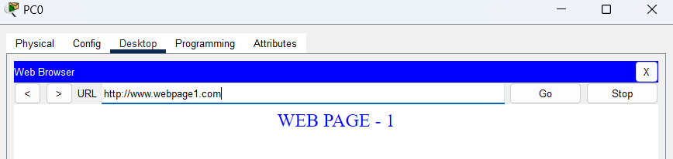

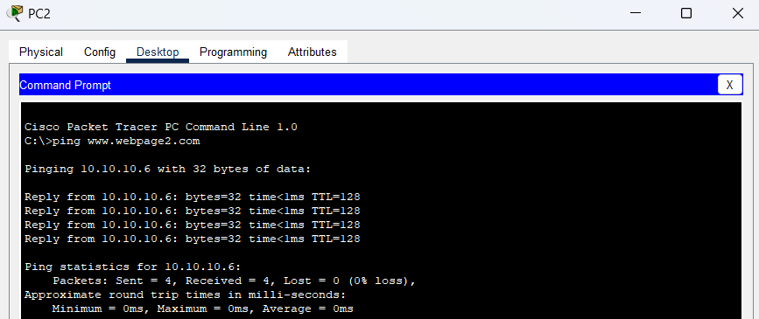

DNS Resolution Efficiency:

DNS resolution efficiency refers to the speed and accuracy with which DNS servers resolve domain names to IP addresses

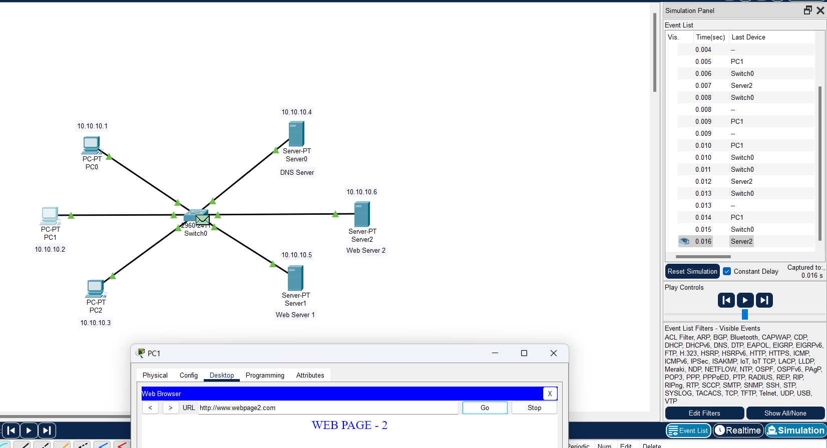

**2. Routing Module:**

Switches are networking devices that connect multiple devices within a single network. Switches use MAC addresses to forward data packets to the correct destination within the same network. Switches maintain MAC address tables that map each device's MAC address to the corresponding switch port.

Routers are networking devices that connect multiple networks together and route data packets between them. Routers use IP addresses to determine the best path for forwarding packets to their destination across different networks.

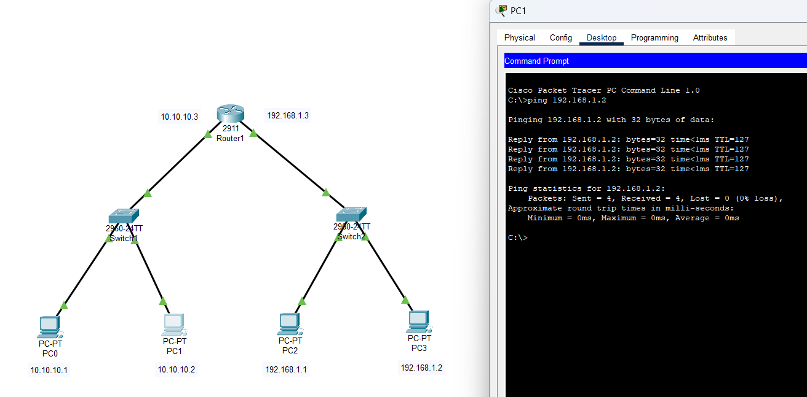

Configuration can be done using CLI commands as well:

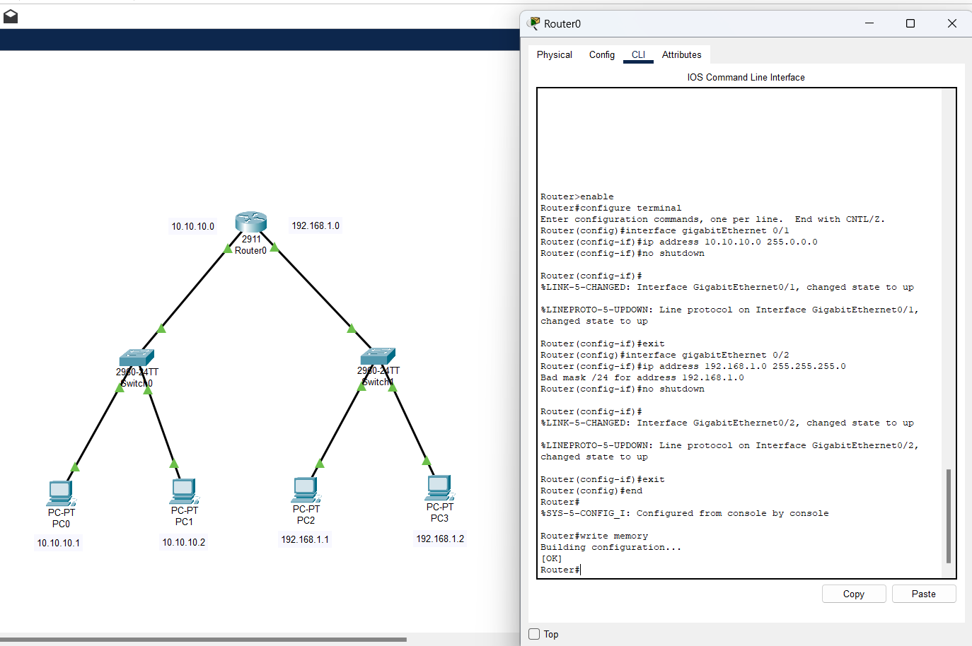

NETWORK EFFICIENCY:

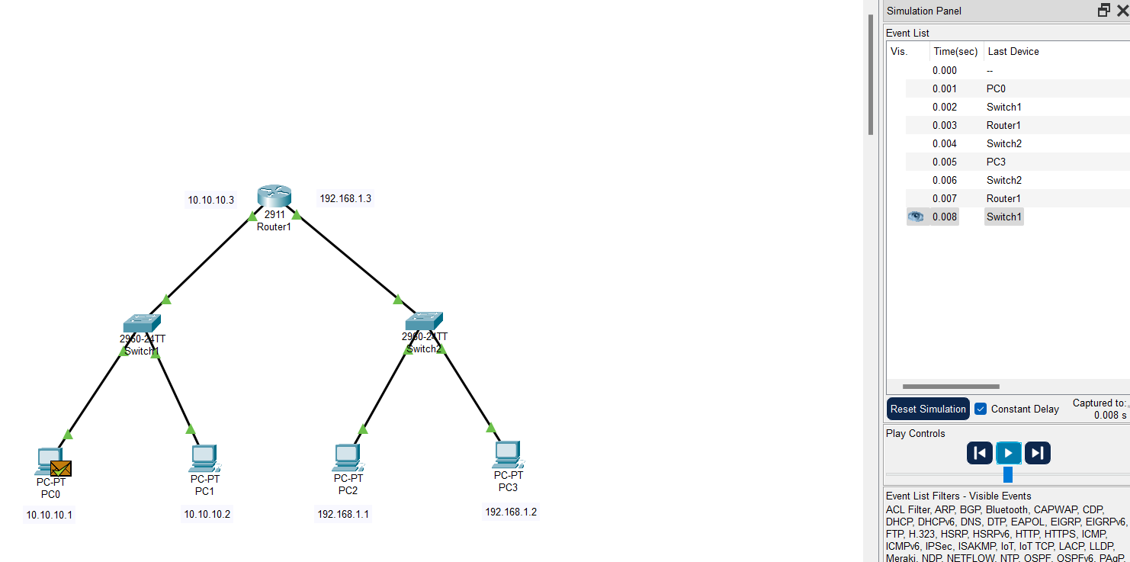

**3. DHCP Module:**

**DHCP (Dynamic Host Configuration Protocol)** is a network protocol used for IP configuration. It enables devices to request and obtain an IP address and other network configuration parameters (such as subnet mask, default gateway, and DNS server) from a DHCP server.

When a device connects to a network, it broadcasts a message to find available DHCP servers. Any DHCP server responds with a offer, providing an IP address and network configuration details. The device then sends a DHCP Request message to accept the offered IP address. Upon receiving the Request, the DHCP server sends an acknowledgment message confirming the IP address assignment and finalizing the configuration. This process allows devices to dynamically obtain IP addresses and network settings without manual configuration, ensuring efficient network connectivity management.

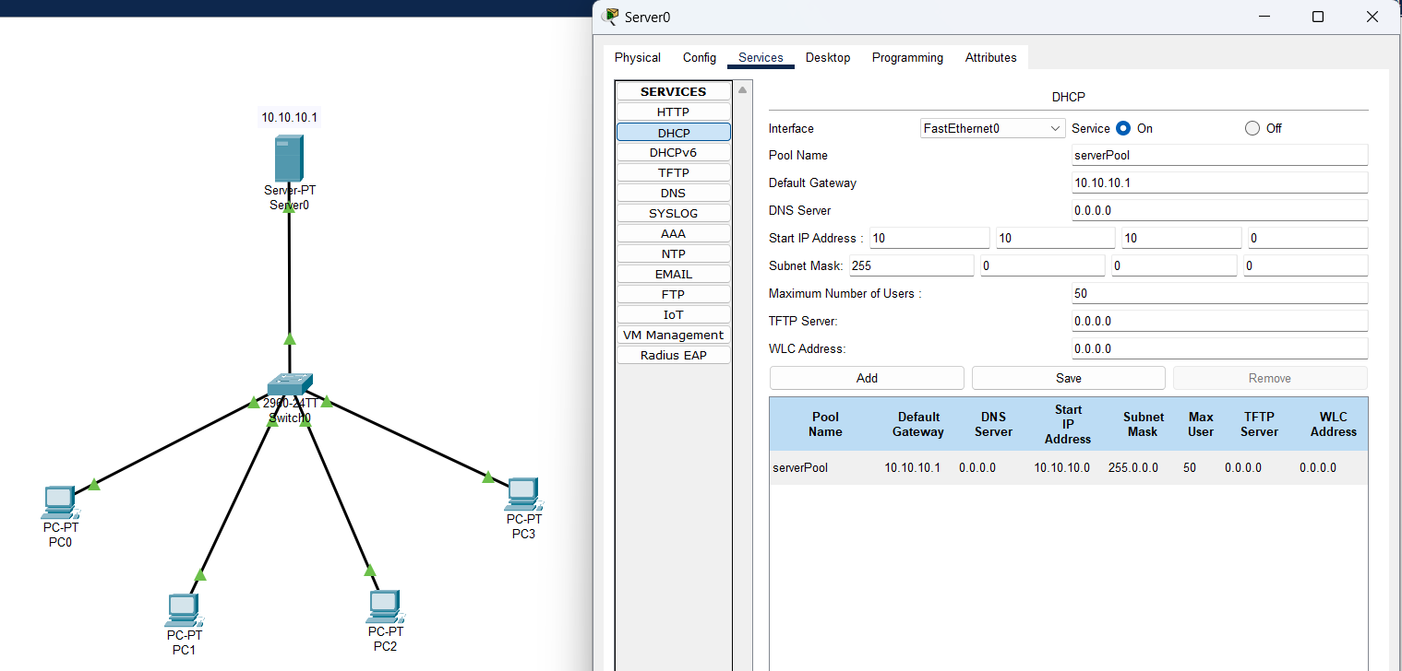

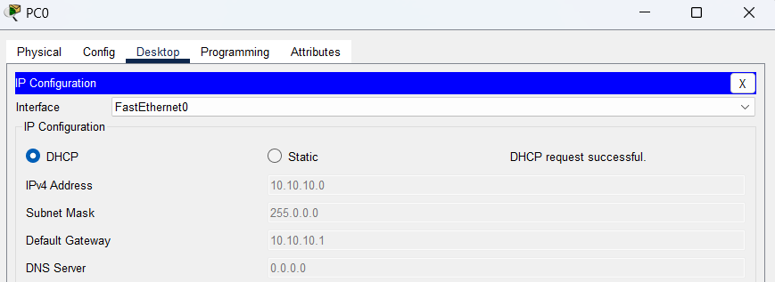

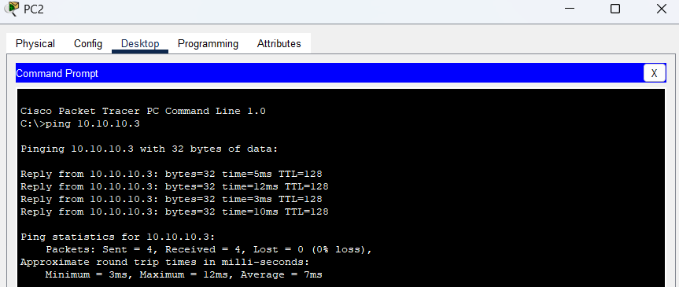

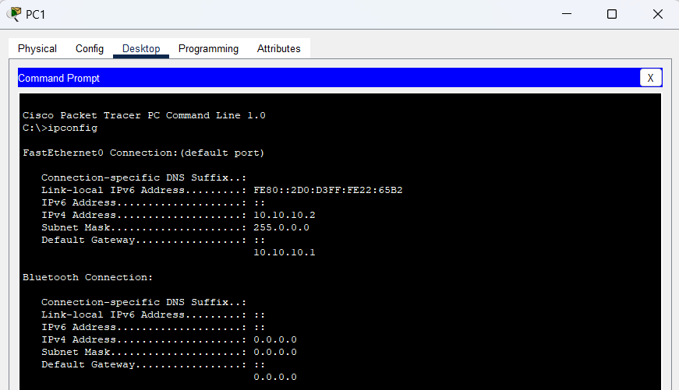

Here is how to configure and modify

1. **Number of IP addresses:**

By adjusting the "Maximum Number of Users" field in the DHCP configuration on the DHCP server to change the number of IP addresses available for allocation.

1. **Name of managing server:**

By changing the "Pool Name" in the DHCP configuration on the DHCP server to update the name of the managing server.

1. **Starting IP address:**

By modifying the "Starting IP Address" field in the DHCP configuration on the DHCP server to change the first IP address in the DHCP pool.

1. **Lease time:**

By adjusting the "Lease Time" field in the DHCP configuration on the DHCP server to change the lease duration.